Highest Good Network v2.0



Expansion.Integration.Friendly

Version 2.0 Documentation

An Open Source Management Network

Index

[**1.0 Introduction** 3](#_Toc423695264)

[**2.0 Highest Good Network (HGN) Overview** 3](#_Toc423695265)

[**3.0 Highest Good Network’s Top priorities** 4](#_Toc423695266)

[**3.1 Partner logging/Hierarchical structure** 4](#_Toc423695267)

[**3.2 Team Discussed High Priority Highest Good Network Web App additions** 4](#_Toc423695268)

[**4.0 Version 2.0 Requirements (v2.0)** 5](#_Toc423695269)

[**4.1 Non-functional Requirements** 5](#_Toc423695270)

[**4.2 Functional requirements** 6](#_Toc423695271)

[**4.2.1 Operations** 7](#_Toc423695272)

[**4.2.2 Highest Good Network (HGN) Projects 2.0** 9](#_Toc423695273)

[**4.2.2.1 V02P01: HGN Core Project 2.0** 9](#_Toc423695274)

[**4.2.2.1.1 V02P01C00: HGN Core Components 2.0** 9](#_Toc423695275)

[**4.2.2.1.2 V02P01C00F00: HGN Core Features 2.0** 10](#_Toc423695276)

[**4.2.2.2 V01P02: HGN Announcements Project 2.0** 14](#_Toc423695277)

[**4.2.2.2.1 V01P02C00: HGN Announcements Components 2.0** 14](#_Toc423695278)

[**4.2.2.2.2 V01P02C00F00: Announcements Features 2.0** 14](#_Toc423695279)

[**4.2.2.3 V01P03: Tasks Project 2.0** 15](#_Toc423695280)

[**4.2.2.3.1 V01P03C00: Tasks Components 2.0** 15](#_Toc423695281)

[**4.2.2.3.1 V01P03C00F00: Tasks Features 2.0** 16](#_Toc423695282)

[**5.0 Logical Design and Implementation Highest Good Network Web Application** 18](#_Toc423695283)

[**6.0 HGN Web Map** 19](#_Toc423695284)

[**7.0 Highest Good Network Database Relational Model** 20](#_Toc423695285)

[**8.0 Relational Schema Highest Good Network Database** 21](#_Toc423695286)

# **1.0 Introduction**

This report presents the basic Highest Good Network’s (HGN) documentation, an open source web application that was developed for One Community Global. The main documents contain a description of the requirements, the project functional logic, and data as well as details of its implementation for the technical understanding of the solution implemented in HGN application are in this report.

The purpose of this documentation is to provide a comprehensive view of features implemented in HGN and encourage the quickly understood for developers interested in develop its features already available.

# **2.0 Highest Good Network (HGN) Overview**

The HGN is an open source and free-shared web-based application that One Community (OCG) is developing for Highest Good collaboration, time tracking, and objective data collection. The software is used to log and organize each of OCG’s teams contribution through on-going records covering all aspects of the growth and evolution of the projects as an open source project-launch blueprinting.

A group of young enthusiast people, Igor Castro, Marco Silva, Matheus Oliveira, and Natalia Costa, developed this version of the web application. In order to offer an automated support for managing activities related to communication and delivery of tasks. Being conceived as a support, this web application should be used under user demand involved with the realization of activities, especially administrators, managers, and team members.

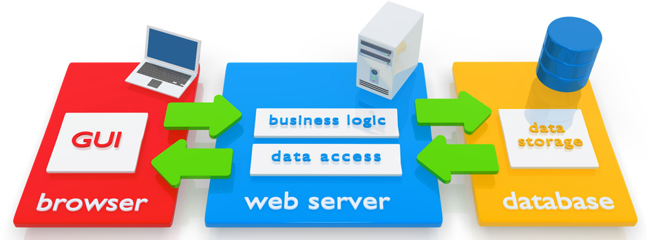There is no software installation, then it is more efficient, it is more secure from the user’s perspective, this means the user can get their hands on the application much quicker. User can start working with the HGN web application when sitting in front of any computer with internet access, and do not have to worry about the working environment. All operations are executed with browser with nothing installed.

# **3.0 Highest Good Network’s Top priorities**

## **3.1 Partner logging/Hierarchical structure**

* Can assign managers and administrators and then place people under those managers;
* Managers can have zero or N (multiple) teams according to the index 0|N;
* Following the Graph Theory where graphs are used to represent networks of communication; Administrators can see the Managers and the managers' team(s); Managers can see their own team(s); and the Team can only see themselves.

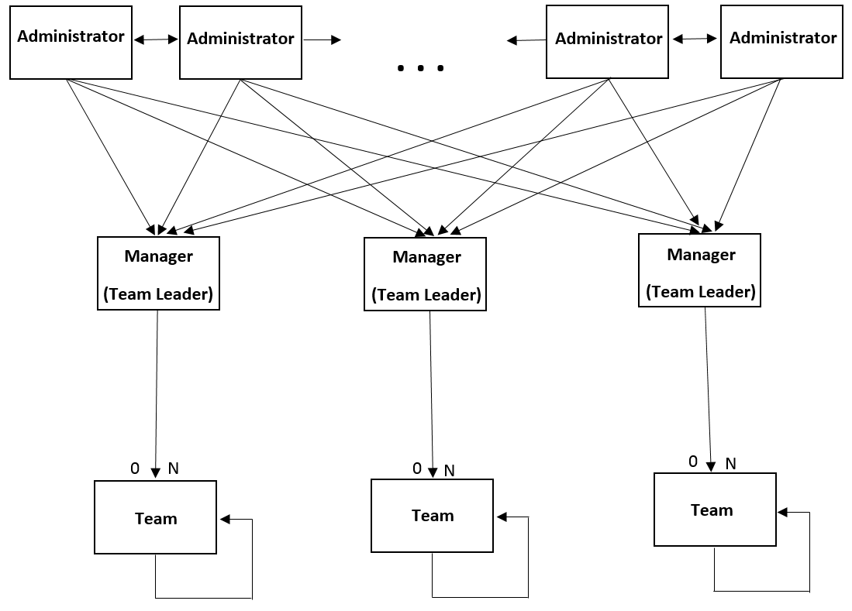

*Hierarchical Structure*

## **3.2 Team Discussed High Priority Highest Good Network Web App additions**

* Total hours log;
* Bar graph of areas of contribution - each area has its own;
* Award/badge system;
* Different chart for week;
* Ability to comment on other people;
* Expanded profile options;
* Scour function for running project specific reports - this scour function should find a designated word and then search prior to that word for a number and grab that number to add to the total for that project.

Example: This line item “3 hrs: Call with Mayke about DCC edits” scour for “DCC” returns input of “3” to be added to Duplicable City Center specific report.

Ability to add names to scour function to expand report inclusions - example “City Center” or “Town Hall” etc.

# **4.0 Version 2.0 Requirements (v2.0)**

## **4.1 Non-functional Requirements**

***Interoperability***, ***maintainability*** and ***accessibility*** were the non-functional priority requirements considered for the development project of the web application. These requirements guide the architecture and technologies used during development, although not establish the services to be made available by the tool.

The approach of Separation of Concerns (SoC) was used during the development of HGN application to ensure ***maintainability***. This approach consists to divide the application into distinct features (Logic elements, content, and presentation, which are essential in web applications.) with as little overlap in functionality as possible. The important factor is minimization of interaction points to achieve high cohesion and low coupling.

Thus, the development of implementation tool was performed with use of the following technologies based on this approach:

* **JavaScript** isan object-oriented computer programming language commonly used to create interactive effects within web browsers;
* **jQuery** is a fast, small, and feature-rich JavaScript library. It makes things like HTML document traversal and manipulation, event handling, animation, and Ajax much simpler with an easy-to-use API that works across a multitude of browsers.
* **Cascading Style Sheets 3** (**CSS3**) is a style sheet language used for describing the look and formatting of a document written in a markup language;
* **Hypertext Markup Language 5** (**HTML5**) is a standardized system for tagging text files to achieve font, color, graphic, and hyperlink effects on World Wide Web pages;
* **PHP** is a widely used open source general-purpose scripting language that is especially suited for web development and can be embedded into HTML;
* **MySQL** is a freely available open source Relational Database Management System (RDBMS) that uses Structured Query Language (SQL);
* **SQL** (**Structured Query Language**) is a special-purpose programming language designed for managing data held in a relational database management system (RDBMS), or for stream processing in a relational data stream management system (RDSMS). It is noted for its quick processing, proven reliability, ease and flexibility of use.

The development configuration with MySQL and PHP was considered to ensure ***interoperability***, as it comes to web application.

In order to meet the ***accessibility*** requirements, the interface design has been developed always looking for present harmoniously information handled following the Flat design style. The response of flat design make us to embrace the real limitations of the digital experience and use this newfound simplicity as a starting to make the web application faster and more functional.

*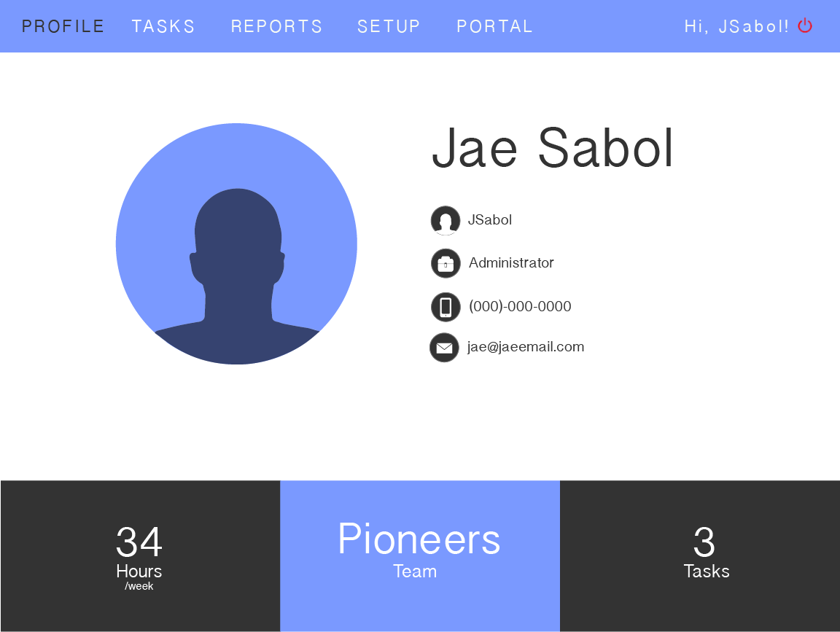An example of the Profile page following the Flat design style.*

## 

## **4.2 Functional requirements**

### **4.2.1 Operations**

***1: User Registration.***

Description: Only the site moderator can register system users.

Input: First Name, Last Name, Login, Type (Administrator, Manager, or Team Member)

Process: The registration will be included in the database.

Output: The new user will be included in the system users list.

***2: Team Registration.***

Description: Only the site moderator can register system teams.

Input: Team Name, team members.

Process: The registration will be included in the database.

Output: The new team will be included in the system teams list.

***3: Update User’s Information by users.***

Description: The user enters the field (First name, last name, email address, phone number, date of birth, and password) where he wants to modify and update it.

Input: The desired field and the new data.

Process: Database Update.

Output: The register will be updated if it has been performed successfully, otherwise the old data will be kept.

***4: Update User’s Information by administrator.***

Description: The user enters the field (First name, last name, email address, phone number, DOB, expected weekly hours, and user type) where he wants to modify and update it.

Input: The desired field and the new data.

Process: Database Update.

Output: The register will be updated if it has been performed successfully, otherwise the old data will be kept.

***5: Update Team’s Information.***

Description: The user administrator enters the field where he wants to modify and update it.

Input: The desired field and the new data.

Process: Database Update.

Output: The register will be updated if it has been performed successfully, otherwise the old data will be kept.

***6: Delete User’s Information.***

Description: The user administrator choose the user he wants to delete and delete it.

Input: The desired field.

Process: Database Update.

Output: The register will be deleted if it has been performed successfully, otherwise the old data will be kept.

***7: Delete Team’s Information.***

Description: The user administrator choose the team he wants to delete and delete it.

Input: The desired field.

Process: Database Update.

Output: The register will be deleted if it has been performed successfully, otherwise the old data will be kept.

***8: Add Task.***

Description: The registered users can add tasks with their name, category, and description.

Input: The user will fill the fields.

Process: The system enters all the data in the database.

***9: Add Subtask.***

Description: The registered users can add subtasks with their name, related task, description, type (tangible or intangible), and time.

Input: The user will fill the fields.

Process: The system enters all the data in the database.

Output: The subtask related to a task will be displayed on screen as a list ordered by entered date.

### **4.2.2 Highest Good Network (HGN) Projects 2.0**

#### **4.2.2.1 V02P01: HGN Core Project 2.0**

The foundational platform of the HGN application, HGN Core includes the basic public-facing webs application functionality as well as the plugins required to provide core user/group features to be available for all subsequent plugins to be built. All other projects and plugins are dependent upon HGN Core.

##### **4.2.2.1.1 V02P01C00: HGN Core Components 2.0**

**V02P01C01: HGN Web Application 2.0**

Underneath all of the functionality of the Highest Good Network is a clean, elegant web application that supports the basic functionality of authentication, user account management, group authorization, navigation, and reports.

**V02P01C02: Plugin Library Plugin 2.0**

As the root plugin, Plugin Library provides access to all other plugins, including information, ability to add to groups in which the user is authorized, and to manage permissions for plugins that the user controls.

**V02P01C03: Group Management Plugin 2.0**

Group Management allows users administrators to update the group, add or remove subgroups, and manage group users.

**V02P01C04: User Browser Plugin 2.0**

User Browser allows users to view the other members of the group.

**V02P01C05: User Profile Plugin 2.0**

User Profile provides an opportunity for users to upload additional information about themselves for others to view, profile photo, phone, email, and day of birth, as well as a log of the user’s activities within the HGN application such as number of tasks per week, group’s name, and number of worked hours per week.

**V02P01C06: Dashboard Management Plugin 2.0**

Dashboard Management allows users to view and create customized dashboard screens composed of pieces of plugin functionality. These dashboards can then be shared amongst group members.

**V02P01C07: Quick Launch Management Plugin 2.0**

Quick Launch Management allows users to customize their quick launch bar for easy access to group plugins.

##### **4.2.2.1.2 V02P01C00F00: HGN Core Features 2.0**

***V02P01C01F00: HGN Website Features 2.0***

**V02P01C01F01: Create Account**

Any administrator user may choose to create an account within the application by providing a first name, last name, login, email address, phone number, date of birth, expected weekly hour, and user type (Admistrator, Manager, and Team Member)

**V02P01C01F02: Update Account**

Any authorized user may choose to change their account information, including first name, last name, email address, phone number, date of birth, profile picture, and password.

**V02P01C01F03: Deactivate Account**

Any administrator user may choose to deactivate their or any other account. The data will be preserved for historical and referential integrity, but the deactivated user credentials may no longer be used to log into the system.

**V02P01C01F04: Log In To Application**

Any authorized user may choose to log into the application by providing valid login and password.

**V02P01C01F05: Log Out Of Application**

Any authorized user may choose to log out of their account at any time. Doing so will time out their session so that further actions requiring authorization may not be taken until they have logged in again.

**V02P01C01F06: View Group Details**

All pages within the HGN application are currently within the context of a group. On a group page, the group’s name, profile picture, and background should be displayed.

**V02P01C01F07: View Group Navigation Options**

According to HGN hierarchy, administrators are able to navigate to the all the groups into the application on a group page. Managers and team members are able to navigate just into their teams.

**V02P01C01F08: Navigate Through Multiple Content Pages**

When there are multiple content pages associated with the current view, forward/back buttons should become visible to the user and allow them to easily navigate amongst the pages.

**V02P01C01F09: View Quick Launch Bar**

On a group page, the user should see either their custom quick launch bar or the group’s default configuration.

**V02P01C01F10: Pretty URLs**

To increase human readability, easy bookmarking, and better search optimization, we should utilize “pretty” URLs rather than those filled with GUIDs or integer identity values.

***V02P01C02F00: Plugin Library Plugin Features 2.0***

**V02P01C02F01: View List of Group Plugins**

Users can view a summary list of all plugins that have been added to the currently selected group.

**V02P01C02F02: View List of Available Plugins**

Users can view a summary list of all plugins available to be added to the currently selected group.

**V02P01C02F03: View Plugin Details**

Users can select a plugin from the list of available plugins  to view additional details about it.

**V02P01C02F04: Add Plugin To Group**

Users can choose to add the plugin to the currently selected group. After adding it to the group, the user will be taken to View Plugin Features so they can choose to manage permissions.

**V02P01C02F05: Remove Plugin From Group**

Users can choose to remove the plugin from the currently selected group. The plugin’s data is retained for historical and referential integrity, but the plugin no longer shows as part of the group. If the same plugin is re-added to the group, it is a new instance of the plugin and will not reference the previous version’s data.

**V02P01C02F06: View Plugin Features**

A plugin’s functionality is partitioned into features that can be individually authorized. Users can view a list of these features and details so that they understand how to apply security to the plugin as they desire.

**V02P01C02F07: Add Authorization To Use Plugin Feature**

For a given plugin feature, administrators users can authorize either an individual or group (current, parent, direct child).

**V02P01C02F08: Remove Authorization To Use Plugin Feature**

Users can remove a plugin feature authorization. The group’s administrator always has authorization to all plugin features and those authorizations cannot be removed.

***V02P01C03F00: Group Management Plugin Features 2.0***

**V02P01C03F01: Update Group**

Any Administrator user can modify the group’s information such as changing any group administrator and controlling visibility (parent group members, current group members, or only group admin).  Defaults can also be set such as new user dashboard(s) and quick launch bar.

**V02P01C03F02: Add Subgroup**

Any Administrator user can create a new group as a direct child of the current group. By default, the group’s creator is its administrator, but a different member of the current group could be chosen instead.

**V02P01C03F03: Remove Subgroup**

Any Administrator user can remove a subgroup from the current group. The data is retained for historical and referential integrity, but the subgroup and all descendent content is no longer accessible through the current group.

**V02P01C03F04: Add User To Group**

Any Administrator user can add other users from the parent group into the current group. The new user receives the default dashboard(s) and quick launch bar that exists at the time they are added.

**V02P01C03F05: Remove User From Group**

Any Administrator user can remove other users from the any group. It should be noted that since members of a group must always be members of all parent groups, removing a user from the current group will also remove them from all child groups. The removed user’s data will be retained for historical and referential integrity, but they will not longer have access or be visible in the current or child groups.

***V02P01C04F00: User Browser Plugin Features 2.0***

**V02P01C04F01: View List Of Group Users**

Users can view the profile of other members of the current group

**V02P01C04F02: Launch User Profile Plugin**

Users can launch directly from User Browser into User Profile in order to view the profile of the selected user within the context of the current group.

*.: Hierarchical Structure: Administrators can see the Managers and the managers' team(s); Managers can see their own team(s); and the Team can only see themselves.  -> Respecting the hierarchical structure*

***V02P01C05F00: User Profile Plugin Features 2.0***

**V02P01C05F01: View User Details**

Users in the same group can view detailed information about other application users such as name, email address, phone number, and date of birth. Any administrator user can view any other member into the application.

**V02P01C05F02: Update User Details**

Users can modify the details that they share with other users such as phone number and date of birth.

**V02P01C05F03: Log User Information**

User Profile exposes API methods for other plugins within HGN to record relevant user activity such as tasks times, comments, etc.

**V02P01C05F04: View User Activity**

Users can view other user’s activity history, sorting and filtering by date, group, and/or plugin respecting the hierarchical structure.

**V02P01C05F05: Set Privacy Setting For Groups and Plugin Activity**

When a user is viewing their own profile, the current filter also has a privacy setting of Public (all can view), Group (members of the source group can view), or Private (only user can view).

**V02P01C05F06: Set Privacy Setting For Activity Item**

When a user is viewing their own profile, each individual activity item also has a privacy setting of Public, Group, Private, or Hide (no user can view within the application). An item cannot have a privacy setting more open than the source group’s or plugin’s privacy setting.

***V02P01C06F00: Dashboard Management Plugin Features 2.0***

**V02P01C06F01: View User Dashboard(s)**

Users can view their previously created dashboard(s) and page through them in a loop. One of the pages in the loop is a dashboard management admin screen.

**V02P01C06F02: Create Dashboard**

On the admin screen, users either can choose to create a new dashboard, “Blank” or by copying one of the dashboards shared within the group. If the user copies a shared dashboard, the data is copied so that the original user may delete their copy without affecting other users who have previously copied it.

**V02P01C06F03: Update Dashboard**

On the admin screen, users can update a dashboard’s name, visibility (private/shared), and position in the list of user dashboards (users always begin viewing the first dashboard and navigate from there).

**V02P01C06F04: Delete Dashboard**

On the admin screen, users can delete a dashboard. All data associated with the dashboard is deleted.

**V02P01C06F05: Add Plugin Piece To Dashboard Work Area**

On the admin screen, for a given dashboard, users can add a plugin piece (a given plugin may offer multiple dashboard pieces). The newly added plugin piece is placed in the work area (to complete the add process, the user must position the new piece from the work area onto the dashboard).

**V02P01C06F06: Remove Plugin Piece From Dashboard**

On the admin screen, for a given dashboard, users can remove a plugin piece from the dashboard to the work area. Pieces still in the work area when the dashboard is saved are officially removed from the dashboard.

**V02P01C06F07: Position Plugin Piece From Work Area Onto Dashboard**

On the admin screen, for a given dashboard, users can select a blank space on the dashboard and choose a plugin piece from the work area to place onto the dashboard. If there are multiple size options available, the user decides how large they’d like the plugin piece to be. If the piece takes up multiple spaces, it is assumed that the space on the dashboard that the user selected will be the top-left corner of the piece.

***V02P01C07F00: Quick Launch Management Plugin Features 2.0***

**V02P01C07F01: Add Plugin To Quick Launch Bar**

Users can add a plugin to the quick launch bar if it is within the current group and not already on the bar.

**V02P01C07F02: Remove Plugin From Quick Launch Bar**

Users can remove a plugin from the current group’s quick launch bar.

**V02P01C07F03: Reorder Plugins On Quick Launch Bar**

Users can adjust the position of plugins already on the quick launch bar for the current group.

#### **4.2.2.2 V01P02: HGN Announcements Project 2.0**

A plugin to allow users to post public messages to group members and group members to read messages posted to the current and child groups. Also includes a dashboard piece for convenient reading.

##### **4.2.2.2.1 V01P02C00: HGN Announcements Components 2.0**

**V02P02C01: Announcements Plugin 2.0**

Announcements allows users to post public messages to group members and group members to read messages posted to the current and child groups.

**V02P02C02: Announcements Reader Piece 2.0**

Announcements Reader is a flexible-sized piece that users can add to their dashboard to easily view messages posted to the current and/or child groups.

##### **4.2.2.2.2 V01P02C00F00: Announcements Features 2.0**

***V02P02C01F00: Announcements Plugin Features 2.0***

**V02P02C01F01: View Announcement Messages**

Users can view all messages within the currently selected group as well as all child groups. Messages are sorted either group-date or date-group, where date is the last updated date. Only messages within the display date range are shown, unless the user is the message’s creator.

**V02P02C01F02: Add Announcement To Group**

Users can add an announcement to the current group, with optional display start/end dates.

**V02P02C01F03: Update Group Announcement**

Users can modify announcements (depending on permissions, either their own or all group) including the message, start/end dates, and whether this change should cause the last updated date to be updated.

**V02P02C01F04: Remove Group Announcement**

Users can remove announcements. Data will be maintained for historical and referential integrity, but the messages will no longer be visible within the system.

***V02P02C02F00: Announcements Reader Piece Features 2.0***

**V02P02C02F01: Modify Reader Settings**

Users can update their settings to control which groups’ messages should be displayed and whether they should be primarily sorted by source group or by last updated date. Groups are ordered alphabetically by name, with the current group appearing first (if it should be displayed).

**V02P02C02F02: View Announcement Messages**

The applicable messages are retrieved and displayed to the user based on the user’s settings.

#### **4.2.2.3 V01P03: Tasks Project 2.0**

A plugin to allow users to manage tasks, track time spent working on them, and view historical data in relevant reports such as user/group contribution history. Also includes dashboard pieces for quickly performing individual aspects of plugin functionality such as quickly recording time spent and viewing time contributions

##### **4.2.2.3.1 V01P03C00: Tasks Components 2.0**

**V02P03C01: Tasks Plugin 2.0**

Tasks is a plugin that allows users to manage tasks, track time spent working on them, and view historical data in relevant reports such as task progress and contribution history.

**V02P03C02: Tasks Viewer Piece 2.0**

Tasks Viewer is a dashboard piece that allows users to view (and set parameters for) a list of group tasks.

**V02P03C03: Time Tracker Piece 2.0**

Time Tracker is a small dashboard piece that allows users to easily record past or current time contributions.

**V02P03C04: Time Viewer Piece 2.0**

Time Viewer is a dashboard piece that allows users to view (and set parameters for) a time contribution report.

##### **4.2.2.3.2 V01P03C00F00: Tasks Features 2.0**

***V02P03C03F00: Tasks Plugin Features 2.0***

**V02P03C01F01: View Group Tasks**

Users can view all of the top-level tasks that have been created under the current group, sorted by name and sorted/filtered by assigned user and status (To do, Done).

**V02P03C01F02: View Task Details**

Users can view a task’s details such as status, description, assigned user, estimated total task time, current time contributed, estimated time remaining, parent group/task, and subtasks.

**V02P03C01F03: View Task Change History**

Users can view a history of all changes to a task (the original values when the task was created as well as all values changed via ‘Update Task’ during the life of the task). All task comments appear in the change history.

**V02P03C01F04: View Task Time Contribution History**

Users can view a task’s history of time contributions. Day, week, month, year, custom duration, or user to provide the desired level of clarity/granularity may group time contributions. Comments connected to time contributions appear when the relevant time contribution is selected. The time contributions are broken down by “starred” and “unstarred”.

**V02P03C01F05: Create Group Task**

Users can create a task for the given group by providing a name. Optional data includes a description, assigned user (the current user is default), and estimated total task time. The current user is recorded as the creator.

**V02P03C01F06: Create Subtask**

Users can create a subtask for a given task by providing a name. Optional data includes a description, assigned user (the current user is default), and estimated total task time. If this is the first subtask created under the given task, a system (read-only) “Task Buffer” subtask will also be added such that the sum of the subtasks always equals the estimate for the parent task (even if the buffer has to be negative). The current user is recorded as the creator.

**V02P03C01F07: Update Task**

Users can update a task’s data fields (name, description, assigned user, and estimated total task time) and add an optional comment to annotate the change. The status can be updated to ‘Completed’ if a reason is provided (‘Done’, ‘Obsolete’). The status can be updated to ‘Closed’ if the user is the creator or has the appropriate permissions. A task can be moved to be a subtask of another task or a subtask can be moved to be a first-level task of the current group. The original and updated values are preserved in the task’s history.

**V02P03C01F08: Add Comment To Task**

Users can directly comment/reply on a task to add any relevant details to the task’s change history.

**V02P03C01F09: Record Previous Time Spent On Task**

Users can record a block of time previously spent on a task by providing the duration and date of activity. They may optionally add a comment to the task to add any relevant details to the task’s change history. They also may optionally “star” the time contribution to differentiate it (as in tangible/billable/etc).

**V02P03C01F10: Track Current Time Working On Task**

Users can track time spent on tasks in real-time by “clocking in” and “clocking out” of the task in the application. They may optionally add a comment to the task to add any relevant details to the task’s change history. They also may optionally “star” the time contribution to differentiate it (as in tangible/billable/etc).

**V02P03C01F11: View Time Contribution History Report**

Users can view a history of time contributions in a dynamic report format, sorting and filtering by user (to see what groups/tasks each user is working on and how much total time they are contributing) or group (to see what users/tasks are working within the group and how much total time is being spent on group tasks). Time contributions may further be grouped by day, week, month, year, or custom duration to provide the desired level of clarity/granularity. The time contributions are broken down by “starred” and “unstarred”

***V02P03C02F00: Tasks Viewer Piece 2.0***

**V02P03C02F01: View Tasks**

Users can view all of the top-level tasks that have been created under the current group and meet the piece’s view query parameters. Tasks can be expanded/collapsed to view/hide subtasks, or selected to launch plugin.

**V02P03C02F02: Set View Parameters**

Users can customize the piece view by adding filters to the query (by assigned user and/or status) and a sort order (by name and, if not filtered, assigned user and/or status).

***V02P03C03F00: Time Tracker Piece 2.0***

**V02P03C03F01: Record Current Time Contribution**

Users may select amongst the tasks that they are assigned to and “clock in”. When finished working, Time Tracker then allows them to “clock out” to confirm the start/end times and submit the time duration. They may optionally add a comment to the task to add any relevant details to the task’s change history. They also may optionally “star” the time contribution to differentiate it (as in tangible/intangible).

**V02P03C03F02: Record Previous Time Contribution**

Users may select amongst the tasks that they are assigned and record a previous time contribution by indicating the duration and date that the contribution occurred. They may optionally add a comment to the task to add any relevant details to the task’s change history. They also may optionally “star” the time contribution to differentiate it (as in tangible/intangible).

***V02P03C03F00: Time Viewer Piece 2.0***

**V02P03C04F01: View Time Contributions**

Users can view all of the time contributions that have been created under the current group and meet the piece’s view query parameters. The time contributions are broken down by “starred” and “unstarred” and can be expanded/collapsed to show/hide the contribution broken down into individual entries (with their associated comments if present).

**V02P03C04F02: Set View Parameters**

Users can customize the piece view by choosing a date range and filter (either by user or by group). If filtering by user, the user sees the time contributions grouped first by group, then by task. If filtering by group, the user sees the time contributions group first by user, then by task.

# **5.0 Logical Design and Implementation Highest Good Network Web Application**

The following architecture / interests organizational structure was used to enable the development of the HGN following the concept of Separation of Interests (SoC):

* Logic: Scripts PHP are used to perform the application logic, numerical processing, queries to the database, section control, etc.
* Data: The data is storage on the server using phpMyAdmin that is a tool written in [PHP](https://en.wikipedia.org/wiki/PHP) intended to handle the administration of [MySQL](https://en.wikipedia.org/wiki/MySQL) with the use of a [web browser](https://en.wikipedia.org/wiki/Web_browser). It can perform various tasks such as creating, modifying or deleting [databases](https://en.wikipedia.org/wiki/Database), [tables](https://en.wikipedia.org/wiki/Table_(database)), [fields](https://en.wikipedia.org/wiki/Field_(computer_science)) or [rows](https://en.wikipedia.org/wiki/Row_(database)); executing [SQL](https://en.wikipedia.org/wiki/SQL) statements; or managing users and permissions.
* Presentation:

# **6.0 HGN Web Map**



Login



Profile



Portal

Setup

Reports

Tasks

*First Level of Abstraction*

# 

# C:\Users\Igor Castro\Desktop\OCG\DB_Relations_v6.png**7.0 Highest Good Network Database Relational Model**

# **8.0 Relational Schema Highest Good Network Database**

team = {team\_id, team\_description, team\_manager, visibility}

user\_team = {user\_team\_id, user\_id, team\_id, visibility}

user = {user\_id, user\_type\_id, user\_login, user\_first\_name, user\_last\_name, user\_DOB, user\_week\_hrs, user\_extra\_hrs, user\_password, user\_tel, user\_mail, visibility, badge\_counter}

user\_type = {user\_type\_id, user\_type\_description}

blue\_square = {bsquare\_id, user\_id, bsquare\_date}

task = {task\_id, task\_status\_id, user\_id, task\_name, task\_description, category\_id, task\_type\_id, task\_beginning\_date, task\_end\_date, visibility}

user\_task = {user\_task\_id, task\_id, user\_id, task\_visibility}

task\_status = {task\_status\_id, task\_status\_description}

task\_type = {task\_type\_id, task\_type\_description}

Category = {category\_id, category\_description}

sub\_task = {sub\_task\_id, task\_id, sub\_task\_name, sub\_task\_description, sub\_task\_time, sub\_task\_date}

comment = {comment\_id, sub\_task\_id, comment\_description, sender\_id, reference\_comment}

# **9.0 User’s Guide**

## **9.1 Login Page**

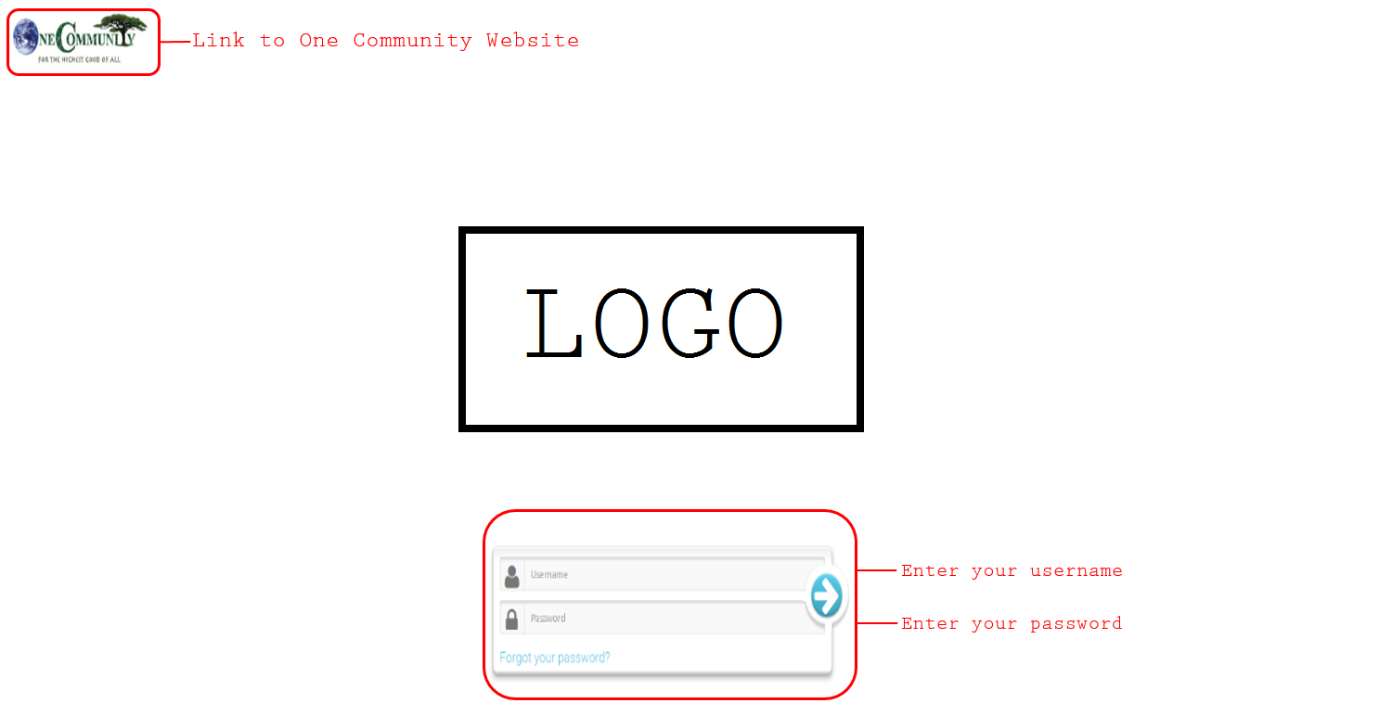

## **9.2 Profile Page**

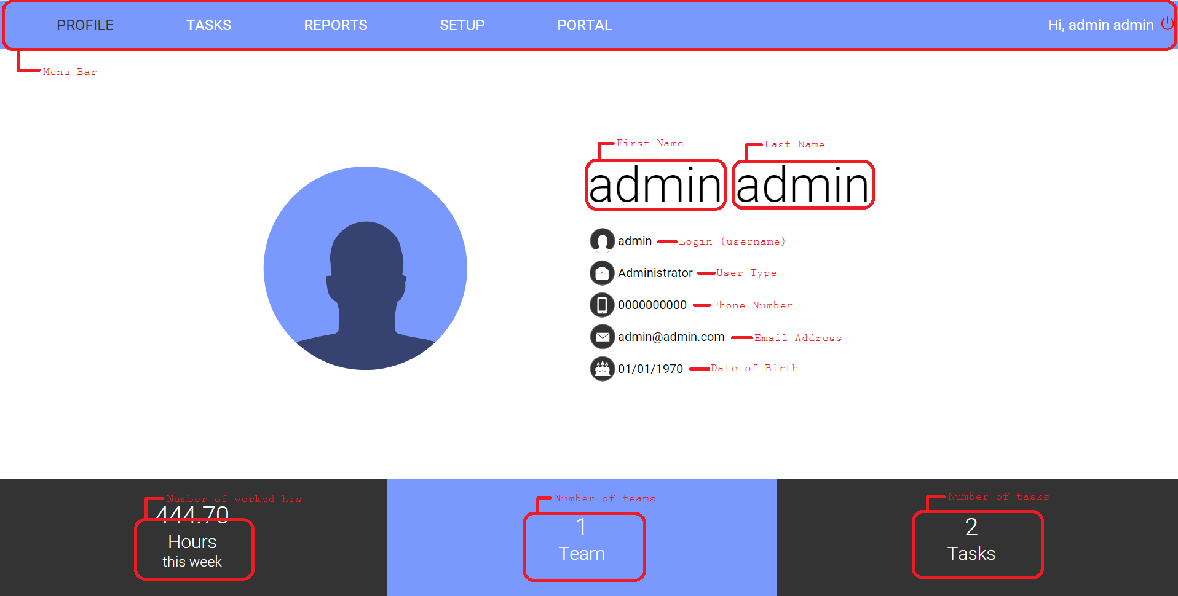

## **9.3 Task Page**

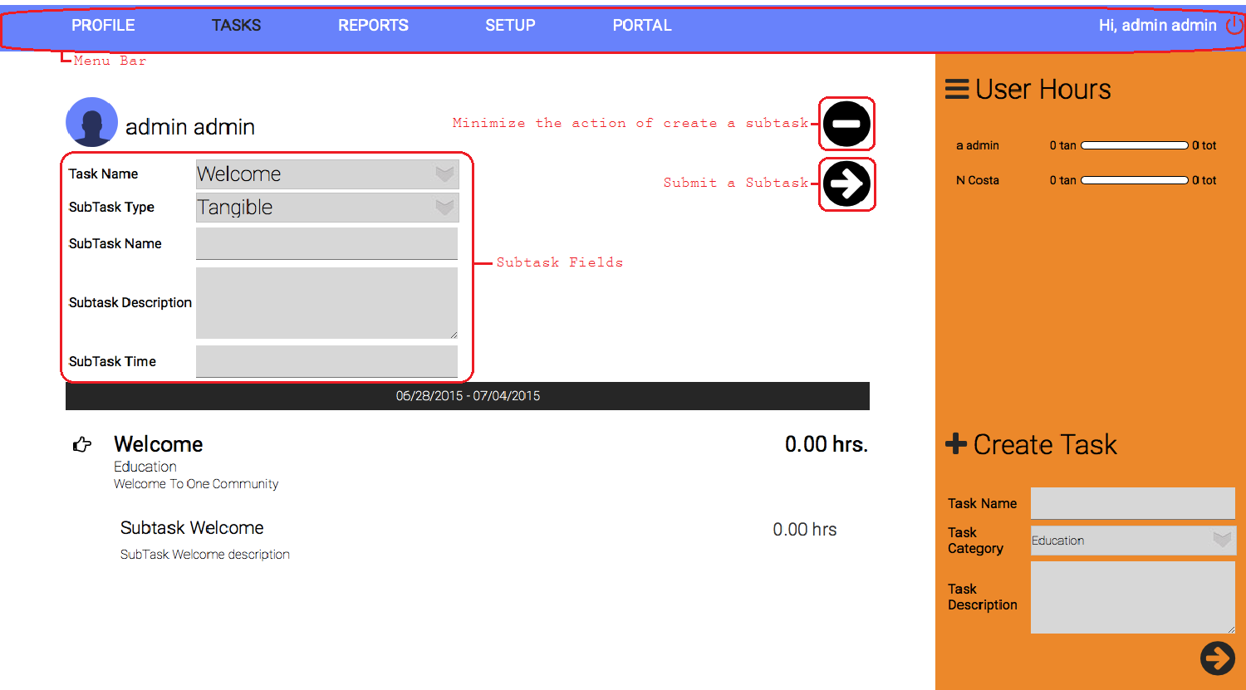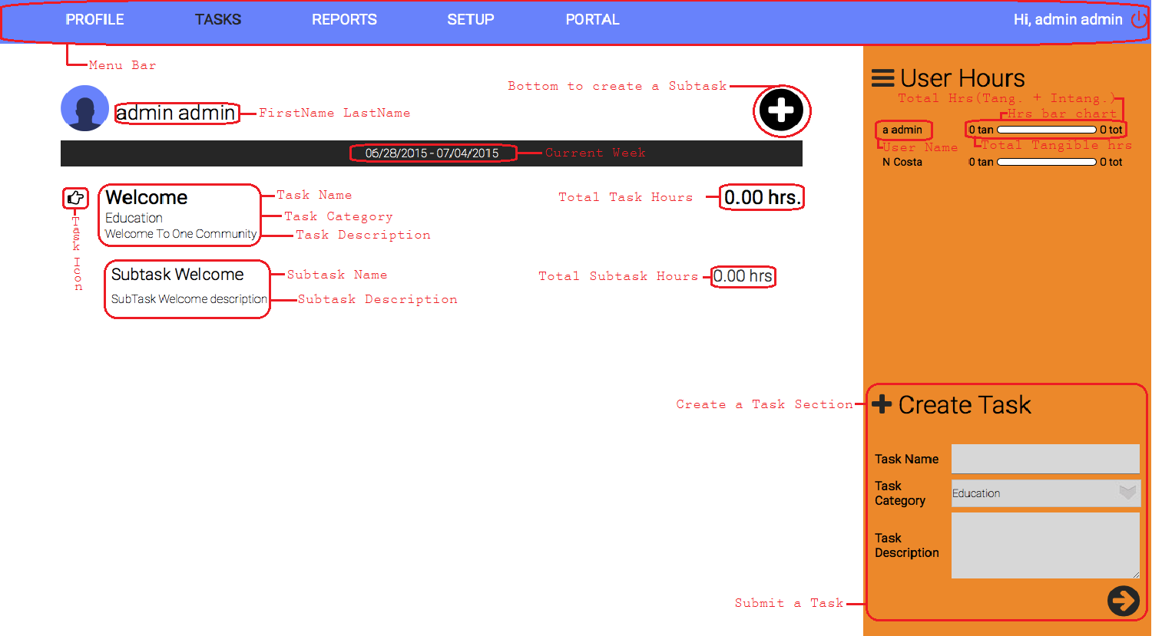

## C:\Users\Igor Castro\Desktop\OCG\ReportGuide.png**9.4 Report Page**

## **9.5 Setup Page**

# **10. Badge System Parameters**

**In Ranked Order of Importance**

1. NEW MAX - PERSONAL RECORD
2. MOST HOURS IN A WEEK
3. NO BLUE SQUARE > 48 MONTHS
4. (X) MINIMUM HOURS > QUINTUPLE
5. 10,000 HOURS TOTAL IN EDUCATION
6. 10,000 HOURS TOTAL IN INFRASTRUCTURE
7. 10,000 HOURS TOTAL IN MARKETING AND PROMOTION
8. 10,000 HOURS TOTAL IN INTERVIEWS AND HOSPITALITY
9. 10,000 HOURS TOTAL IN FUNDING AND PARTNERSHIP BUILDING
10. 5,000 HOURS TOTAL IN EDUCATION
11. 5,000 HOURS TOTAL IN INFRASTRUCTURE
12. 5,000 HOURS TOTAL IN MARKETING AND PROMOTION
13. 5,000 HOURS TOTAL IN INTERVIEWS AND HOSPITALITY
14. 5,000 HOURS TOTAL IN FUNDING AND PARTNERSHIP BUILDING
15. NO BLUE SQUARE > 36 MONTHS
16. (X) MINIMUM HOURS > QUADRUPLE
17. 3,000 HOURS TOTAL IN EDUCATION
18. 3,000 HOURS TOTAL IN INFRASTRUCTURE
19. 3,000 HOURS TOTAL IN MARKETING AND PROMOTION
20. 3,000 HOURS TOTAL IN INTERVIEWS AND HOSPITALITY
21. 3,000 HOURS TOTAL IN FUNDING AND PARTNERSHIP BUILDING
22. NO BLUE SQUARE > 24 MONTHS
23. (X) MINIMUM HOURS > TRIPLE
24. 2,000 HOURS TOTAL IN EDUCATION
25. 2,000 HOURS TOTAL IN INFRASTRUCTURE
26. 2,000 HOURS TOTAL IN MARKETING AND PROMOTION
27. 2,000 HOURS TOTAL IN INTERVIEWS AND HOSPITALITY
28. 2,000 HOURS TOTAL IN FUNDING AND PARTNERSHIP BUILDING
29. NO BLUE SQUARE > 12 MONTHS
30. (X) MINIMUM HOURS > DOUBLE
31. 90 HR STREAK 4 WEEKS RUNNING
32. 90 HR STREAK 3 WEEKS RUNNING
33. 90 HR STREAK 2 WEEKS RUNNING
34. 90 HRS IN 1 WEEK
35. 1,000 HOURS TOTAL IN EDUCATION
36. 1,000 HOURS TOTAL IN INFRASTRUCTURE
37. 1,000 HOURS TOTAL IN MARKETING AND PROMOTION
38. 1,000 HOURS TOTAL IN INTERVIEWS AND HOSPITALITY
39. 1,000 HOURS TOTAL IN FUNDING AND PARTNERSHIP BUILDING
40. 80 HR STREAK 20 WEEKS RUNNING
41. 80 HR STREAK 15 WEEKS RUNNING
42. 80 HR STREAK 10 WEEKS RUNNING
43. 80 HR STREAK 6 WEEKS RUNNING
44. 80 HR STREAK 4 WEEKS RUNNING
45. 80 HR STREAK 3 WEEKS RUNNING
46. 80 HR STREAK 2 WEEKS RUNNING
47. 80 HRS IN 1 WEEK
48. 600 HOURS TOTAL IN EDUCATION
49. 600 HOURS TOTAL IN INFRASTRUCTURE
50. 600 HOURS TOTAL IN MARKETING AND PROMOTION
51. 600 HOURS TOTAL IN INTERVIEWS AND HOSPITALITY
52. 600 HOURS TOTAL IN FUNDING AND PARTNERSHIP BUILDING
53. 70 HR STREAK 40 WEEKS RUNNING
54. 70 HR STREAK 20 WEEKS RUNNING
55. 70 HR STREAK 15 WEEKS RUNNING
56. 70 HR STREAK 10 WEEKS RUNNING
57. 70 HR STREAK 6 WEEKS RUNNING
58. 70 HR STREAK 4 WEEKS RUNNING
59. 70 HR STREAK 3 WEEKS RUNNING
60. 70 HR STREAK 2 WEEKS RUNNING
61. 70 HRS IN 1 WEEK
62. 400 HOURS TOTAL IN EDUCATION
63. 400 HOURS TOTAL IN INFRASTRUCTURE
64. 400 HOURS TOTAL IN MARKETING AND PROMOTION
65. 400 HOURS TOTAL IN INTERVIEWS AND HOSPITALITY
66. 400 HOURS TOTAL IN FUNDING AND PARTNERSHIP BUILDING
67. 60 HR STREAK 80 WEEKS RUNNING
68. 60 HR STREAK 60 WEEKS RUNNING
69. 60 HR STREAK 40 WEEKS RUNNING
70. 60 HR STREAK 20 WEEKS RUNNING
71. 60 HR STREAK 15 WEEKS RUNNING
72. 60 HR STREAK 10 WEEKS RUNNING
73. 60 HR STREAK 6 WEEKS RUNNING
74. 60 HR STREAK 4 WEEKS RUNNING
75. 60 HR STREAK 3 WEEKS RUNNING
76. 60 HR STREAK 2 WEEKS RUNNING
77. 60 HRS IN 1 WEEK
78. 200 HOURS TOTAL IN EDUCATION
79. 200 HOURS TOTAL IN INFRASTRUCTURE
80. 200 HOURS TOTAL IN MARKETING AND PROMOTION
81. 200 HOURS TOTAL IN INTERVIEWS AND HOSPITALITY
82. 200 HOURS TOTAL IN FUNDING AND PARTNERSHIP BUILDING
83. 50 HR STREAK 200 WEEKS RUNNING
84. 50 HR STREAK 150 WEEKS RUNNING
85. 50 HR STREAK 100 WEEKS RUNNING
86. 50 HR STREAK 80 WEEKS RUNNING
87. 50 HR STREAK 60 WEEKS RUNNING
88. 50 HR STREAK 40 WEEKS RUNNING
89. 50 HR STREAK 20 WEEKS RUNNING
90. 50 HR STREAK 15 WEEKS RUNNING
91. 50 HR STREAK 10 WEEKS RUNNING
92. 50 HR STREAK 6 WEEKS RUNNING
93. 50 HR STREAK 4 WEEKS RUNNING
94. 50 HR STREAK 3 WEEKS RUNNING
95. 50 HR STREAK 2 WEEKS RUNNING
96. 50 HRS IN 1 WEEK
97. CHIEF (Lead a team of 40+)
98. 100 HOURS TOTAL IN EDUCATION

100. 100 HOURS TOTAL IN INFRASTRUCTURE

102. 100 HOURS TOTAL IN MARKETING AND PROMOTION

1. 100 HOURS TOTAL IN INTERVIEWS AND HOSPITALITY
2. 100 HOURS TOTAL IN FUNDING AND PARTNERSHIP BUILDING
3. 40 HR STREAK 200 WEEKS RUNNING
4. 40 HR STREAK 150 WEEKS RUNNING
5. 40 HR STREAK 100 WEEKS RUNNING
6. 40 HR STREAK 80 WEEKS RUNNING
7. 40 HR STREAK 60 WEEKS RUNNING
8. 40 HR STREAK 40 WEEKS RUNNING
9. 40 HR STREAK 20 WEEKS RUNNING
10. 40 HR STREAK 15 WEEKS RUNNING
11. 40 HR STREAK 10 WEEKS RUNNING
12. 40 HR STREAK 6 WEEKS RUNNING
13. 40 HR STREAK 4 WEEKS RUNNING
14. 40 HR STREAK 3 WEEKS RUNNING
15. 40 HR STREAK 2 WEEKS RUNNING
16. 40 HRS IN 1 WEEK
17. TRAILBLAZER (Lead a team of 30+)
18. 30 HR STREAK 200 WEEKS RUNNING
19. 30 HR STREAK 150 WEEKS RUNNING
20. 30 HR STREAK 100 WEEKS RUNNING
21. 30 HR STREAK 80 WEEKS RUNNING
22. 30 HR STREAK 60 WEEKS RUNNING
23. 30 HR STREAK 40 WEEKS RUNNING
24. 30 HR STREAK 20 WEEKS RUNNING
25. 30 HR STREAK 15 WEEKS RUNNING
26. 30 HR STREAK 10 WEEKS RUNNING
27. 30 HR STREAK 6 WEEKS RUNNING
28. 30 HR STREAK 4 WEEKS RUNNING
29. 30 HR STREAK 3 WEEKS RUNNING
30. 30 HR STREAK 2 WEEKS RUNNING
31. TORCHBEARER (Lead a team of 25+)
32. NO BLUE SQUARE > 6 MONTHS
33. LOGGED TIME IN > 3 DIFFERENT CATEGORIES
34. TRENDSETTER (Lead a team of 20+)
35. LOGGED TIME IN > 4 DIFFERENT CATEGORIES
36. LEADER (Lead a team of 15+)
37. LOGGED TIME IN > 5 DIFFERENT CATEGORIES
38. ORGANIZER (Lead a team of 10+)
39. LOGGED TIME IN > 6 DIFFERENT CATEGORIES
40. FACILITATOR (Lead a team of 5+)
41. NO BLUE SQUARE > 3 MONTHS